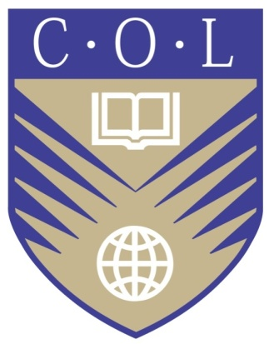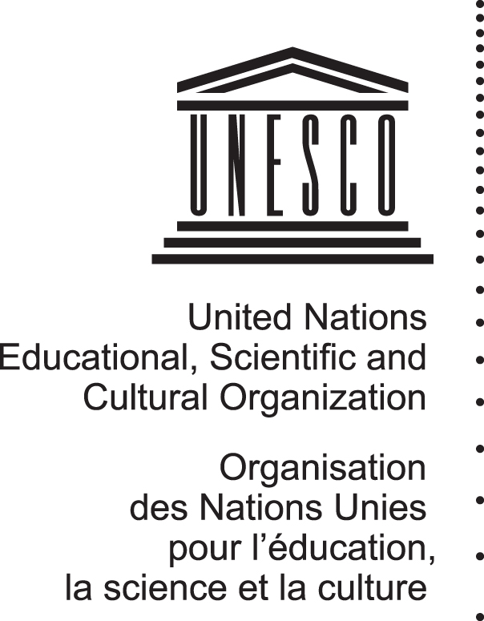

Fostering Governmental Support for Open Educational Resources Internationally (FGSOERI)

Commonwealth of Learning (COL) and UNESCO

Regional Policy Forum for Latin America
Rio de Janeiro, Brazil
28-29 March 2012

REPORT

Regional Policy Forum for Latin America
Rio de Janeiro, Brazil
28-29 March 2012

REPORT

Background
The project Fostering Governmental Support for Open Educational Resources Internationally (FGSOERI), is organising six regional policy forums (RPF), one in each UNESCO region, between January and May 2012.

The third regional policy forum, for Latin America, was held Rio de Janeiro, Brazil, from 28 to 29 March 2012.

This RPF was co-organised by UNESCO (HQs and UNESCO Offices in Brazil, Chile and Uruguay) and the Commonwealth of Learning (COL) and hosted by the University Gama Filho, which provided the venue and expertise. Sponsorship for the event was provided by:
- Municipality of Rio de Janeiro,
- Telefonica Foundation,
- Universidade Gamo Filho,
- Núcleo de Informática Aplicada à Educação (NIED),
- Universidade Estadual de Campinas; and
- REA Brazil.

The present report conveys the recommendations that Latin America made to the project and details Latin American inputs to version 3 of the Paris Declaration, which was drafted after the RPF, posted with the invitation to comment until 7 April and then finalised for presentation to the RPF for Europe on 17 April.

Participants
The Forum brought together some 80 participants representing both OER practitioners and government policy-makers. The discussions were interpreted simultaneously into Portuguese, Spanish and English.

Government representatives from seven Member States participated in the Forum: Brazil, Chile, Costa Rica, El Salvador, Guatemala, Paraguay and Uruguay. Guatemala was represented by Honourable Cynthia Del Aguila, Minister of Education.
(Annex1: List of participants).

The programme was structured so as to promote a dialogue between governments and practitioners.
(Annex 2: Agenda).

Information base
Replies to the Survey

By the time this RPF was held the project had received replies to the Survey from 11 Latin American countries: Argentina, Brazil, Chile, Colombia, Costa Rica, El Salvador, Guatemala, Mexico, Paraguay, Peru and Uruguay.

All participants were given the draft Declaration produced after the Africa RPF, as well as a background note for the project and a flyer for the 2012 World OER Congress. A dedicated web-space (http://oercongress.weebly.com) was created for the project and is being updated regularly, as each Regional Policy Forum occurs.

DAY 1: 28 March 2012

Opening Ceremony
Abel Caine opened the Forum on behalf of UNESCO and thanked the hosts and sponsors.

• Claudia Costin, Municipal Secretary of Education, Rio de Janeiro
• Fábio Mazzonetto, Director of Post-Graduation Courses at Gama Filho University
• Januario Montone, Municipal Secretary of Health, São Paulo
• Sir John Daniel, Commonwealth of Learning (COL)
• Márcio Mendes Costa, Gama Filho University’s Dean
• Mila Gonçalves, Telefonica Foundation

Claudia Costin, Municipal Secretary of Education, State of Rio de Janeiro, detailed some of the challenges facing education in Brazil. Ms. Costin noted that Brazil’s low ranking in the PISA assessment is not worthy of the world’s 6th economy, which must aim to raise the quality of education at all levels. She emphasized that the quality of education depended on the quality of teachers and that teachers must receive adequate support and incentives to be co-participants in the education process. With regard to OER, she admitted that although teaching materials are posted on the Internet, on the Teachers Portal (Portal do Profesor), they are not formally open since copyright applies.

Keynote presentation
Following the Opening Ceremony, Sir John Daniel, President and CEO of COL and Stamenka Uvalic-Trumbic, Senior Consultant COL, gave the background, objectives and elements of the project and provided a brief analysis of the replies to the survey that had been received.
(http://www.col.org/resources/speeches/2012presentations/Pages/2012-03-28.aspx)

The ensuing discussion revealed the gaps of perception and experience between the grassroots communities promoting OER and government representatives. A telling example was that the Creative Commons representative from Guatemala met the Guatemalan Minister of Education for the first time at this Rio Forum.

Panel 1: OER and public policies (plenary)
Moderator:
The panel was moderated by Januario Montone, Municipal Secretary of Health, State of Sao Paolo, who began by giving a detailed account of Sao Paulo’s Health system.

The panel included:

- Carolina Rossini, OER Brazil. She presented Brazilian Challenges and Perspectives related to OER, stressing that Brazil’s experimentation with openness is at an early stage. She categorized the challenges as: legal &copyright, economic sustainability, and the perspectives of teachers. She noted the importance of interoperability and argued that learning resources paid for by public resources should be open to all. She underlined that discussion are underway to include OER in the National Plan for Education.

- Kathleen Omollo (University of Michigan) and Gregory Earle Doyle (University of Cape Town), OER Alliance Africa. They emphasized the challenges facing health education in Africa and reported how OER Africa has supported 10 African institutes to come together in order to produce materials and use them in general pedagogy as OER on a voluntary basis. Because of the comparative advantage of African materials in the field of tropical disease, these OER are used at the University of Michigan.

- Helmut Evanir Bergenthal Roman, Ministry of Education Paraguay presented the Education Portal of the Ministry of Education. The Portal supplies educational resources for classroom teachers to make their work easier. He said that Paraguay fosters the creation of OER by teachers. Teachers are key to the advancement of education but need capacity-building and incentives. Open licenses already exist and many use Creative Commons licenses. He closed by paraphrasing Antonio Machado, the Spanish poet, that “the only thing that is lost is what we keep; we only gain what we give”

- Werner Westermann Juarez, Director, Educalibre, Chile, and advisor of the Ministry of Education, presented the Educar Chile Portal and emphasized that it was limited in scope and access, which is true for most of Latin America, Paraguay being an exception. Civil society urges changing the terms and conditions of access through the use of OER. Existing resources are not as helpful as they could be if they stimulated a relationship between students and teachers, which would be possible if teachers had the freedom to adapt these resources.

- Rafael Parente, Deputy Secretary Educopedia, Brazil, presented Educopedia, which was developed for the education of children, young and adults. It offers courses in different subjects including extracurricular activities and guidance. Teachers can customize lessons, although they need to log in through the Ministry of Education.

- Xavier Antonio Ochoa Chebab, Ecuador Polytechnical University, emphasized the 4 Rs of OER: reuse, redistribute, revise and remix and gave solid arguments why governments should use them, mentioning that only 10% of textbooks used in Latin America were produced in Latin America, while the rest are foreign and often not relevant. He underlined that the cost of textbooks is about 5% of the minimum wage, so that OER are the only solution.

Group sessions on draft Declaration
The Forum participants worked in two breakout groups to discuss the outline Declaration: 1. Representative of governments; 2. Representatives of civil society.

Group 1: Governments
Chair: Sir John Daniel (COL)
Rapporteur: Cynthia Del Aguila, Minister of Education of Guatemala

Summary:
- Include definitions for: open license, public domain, open standards
- Use simple language for the actions recommended without too many details
- Promote the development of appropriate ‘legal frameworks’ rather than open licenses
- Include only quality-assured material in repositories
- Add another paragraph about fostering OER within and between different cultures and languages.
- Refer to strategic alliances rather than business models
- Stress the imperative of sustainability.
- Encourage the private sector and NGOs to license material openly.
- Create material for use and exchange between countries in an open way without restrictions
- Research and assess the use and impact of OER material and learning

Group 2: Civil Society
Rapporteur: Carolina Rossini

Summary:
- Include a glossary in the Preamble.
- Improve the translation between English, Portuguese and Spanish.
- Distinguish between ‘open’ and ‘free’.
- Standardize the term for OER in Portuguese.
- Stress the importance of the contribution of OER to informal education.
- Foster public-private partnerships for OER.

Group 2 did not complete its review of the draft Declaration and undertook to provide written comments after the Forum.

DAY 2: 29 March 2012
Panel 2 – OER Plural perspectives
Chair: Abel Caine, UNESCO.
It included the following panellists:

Prof. José Luis Sanchez, Universidad Gamo Filho presented on two ongoing projects :
- The largest digital library in Brazil (1 million items, 1.435 universities, 48 thousand journals, 62 countries)
http://www.posugf.com.br/biblioteca/
- Online course about “Use of new technologies in elementary and high school”

Prof. María Eugenia Núñez, Argentina presented on the portal INTEGRAR (www.integrar.bue.edu.ar)
A digital platform created by the Ministry of Education of the City of Buenos Aires, which invites the community to participate in building educational resources. Teachers, principals, students and parents or anyone else can contribute, by sending resources to publish, including references to material available on the web, or voting proposals that seem most interesting. The proposal, open to the entire community, seeks to incorporate diversity in educational resources through the plurality of materials and participatory knowledge.

Pilar Sáenz from Karisma Foundation described their work with different institutions in Latin America and their support for OER projects by providing legal and technical advice. They also create tools to promote the use of OER and the use of Open licenses and develop innovative research projects on OER.

Tel Amiel of NIED/UNICAMP highlighted the difficulties faced by non-English speakers as the major part of OER is in English and based on Western culture. Translation is needed for “access” and cultural context have to be taken into account. He foresaw two primary objectives:
- Larger availability of OER
- Definition of parameters regarding open licenses

Paulo Teixera, Congressman and federal representative of the City of Sao Paolo made a most impressive account of the draft bill 1513/2011, which stipulates that those who receive money from the public budget have the responsibility to share their research with others. If they are educational resources they must have free technical standards to allow interoperability. He expressed his hope that the Bill will be approved this year, as there was no account of much opposition to it.

Presentation: World Open Educational Resources Congress
Abel Caine (UNESCO HQ) presented the OER Congress and the process leading to the drafting of the Paris Declaration.
Wrap-Up and Way Forward
In his concluding remarks Sir John Daniel detailed the next steps in the project and expressed his great pleasure at the richness, the outputs and the high standards of the discussions.
The next steps are:
- The redrafted Paris Declaration v.3 will be made available for comments for a period of one week (until 7 April) on the OER Congress Weebly;
- The finalised Declaration v.3 will be presented to the Europe Forum for further input in mid-April
- A draft of the Declaration reflecting the input of the Regional Policy Forums will be submitted to the International Advisory and Liaison Group (IALG) at its meeting on 11 May 2012. This Group will also constitute the Drafting Group at the Congress itself.
- A Summary Report from the Latin America Forum will be produced and posted within ten days; this report, together with the Declaration v.3 will constitute the specific input from Latin America.
(Annex 3: Paris Declaration v.3)

Stamenka Uvalić-Trumbić
Senior Consultant
2012-04-10

Annexes:
- List of participants
- Agenda
- Paris Declaration v.3 (revised version)

